Tender texts as templates for construction projects in which a tender will be issued  Product:  CORTIFLEX160  L-Shape | 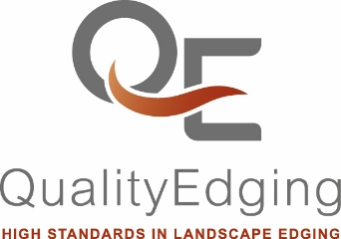

Path and flower bed metal laser cut edging made of Corten steel, Cortiflex® profile,
straight shape, deliver and install in accordance with the manufacturer's installation instructions.
Flexible profile with square holes for screwing in concrete and ground anchors and other accessories.

Item: Corten steel rail with 6 laser-cut anchor / connection screw holes
Item no.: C160N24
Profile height: 160 mm
Length: 2,400 mm
Thickness: 3 mm
Colour: Steel grey, rusting
Item: Connector with 4 laser-cut anchor / connection screw holes
Item no.: CV140
Profile height: 60 mm
Length: 140 mm
Thickness: 3 mm
Colour: Steel grey, rusting
Item: Concrete and ground anchor with 2 laser-cut anchor / connection screw holes
for 90°-fastening the 105, 160, 200 and 300 mm profiles
Item no.: CKA10
Width: 30 mm
Length: 200 mm
Thickness: 3 mm
Round hole: Ø 7.5 mm
Colour: Steel grey, rusting
Item: M8 screw, washer + screw nut
Item no.: SV2AM8100
Length: approx. 20 mm
Material: V2A stainless steel
Manufacturer:QualityEdging FZ LLC
Tel./WhatsApp: +971 50 3464005
www.qualityedging.com
E-Mail: sales@qualityedging.com
Compass Building, Al Shohada Road
Al Hamra Industrial Zone
Ras Al Khaimah, United Arab Emirates

